**AZURE ACTIVE DIRECTORY**

**INTRODUCTION**

* Snapshots
* Disk restore point
* Disk types cheap to expensive (**HDD Standar, SSD Standar, SSD Premiun, Ultra Disk**)
* https://learn.microsoft.com/es-es/azure/virtual-machines/disks-types

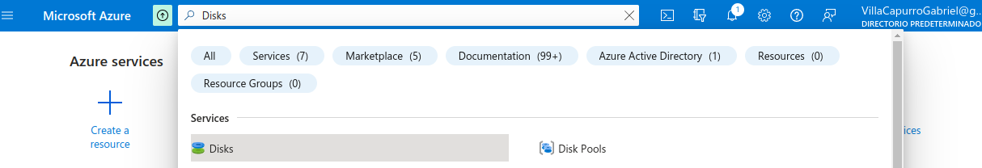

1. Create a disk

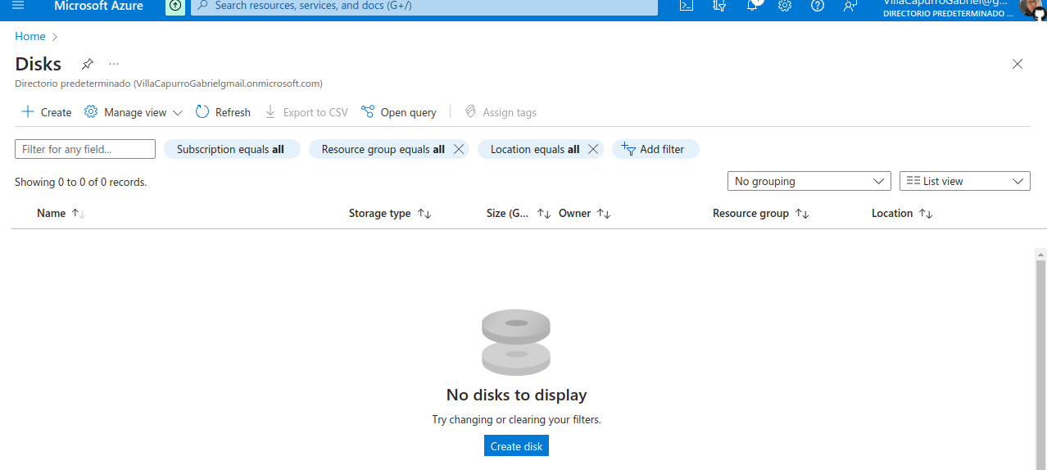

Availability zone if we want to replicate the disk in other zones

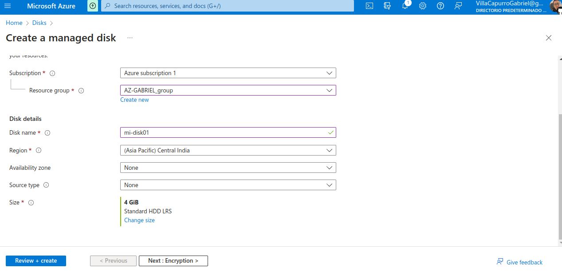

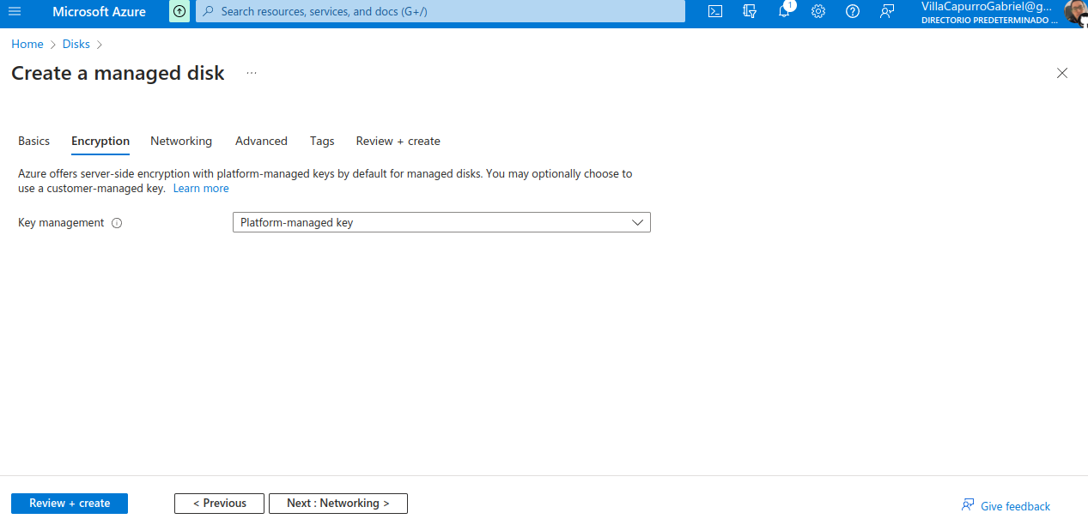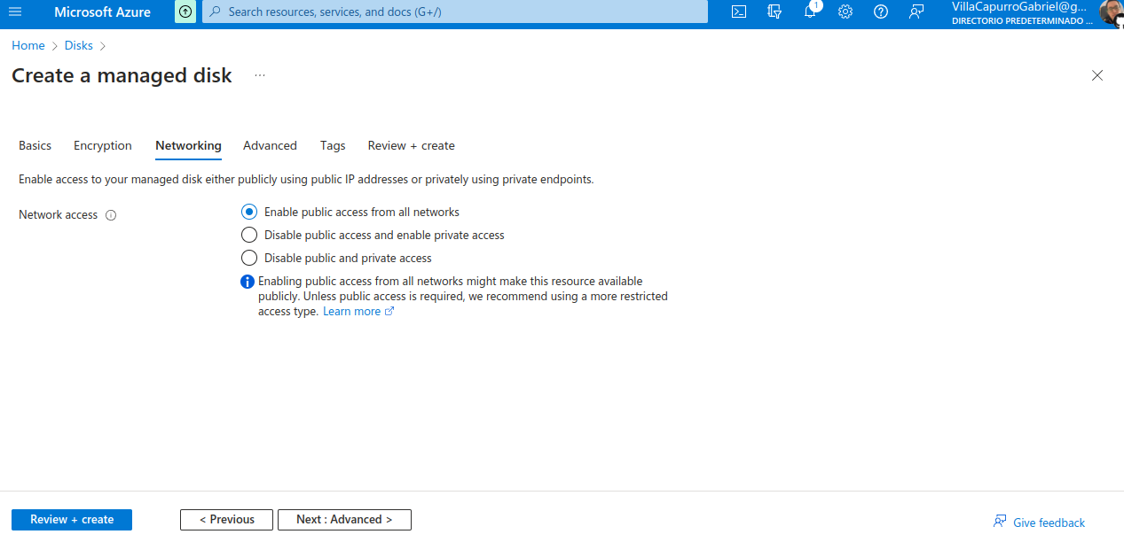

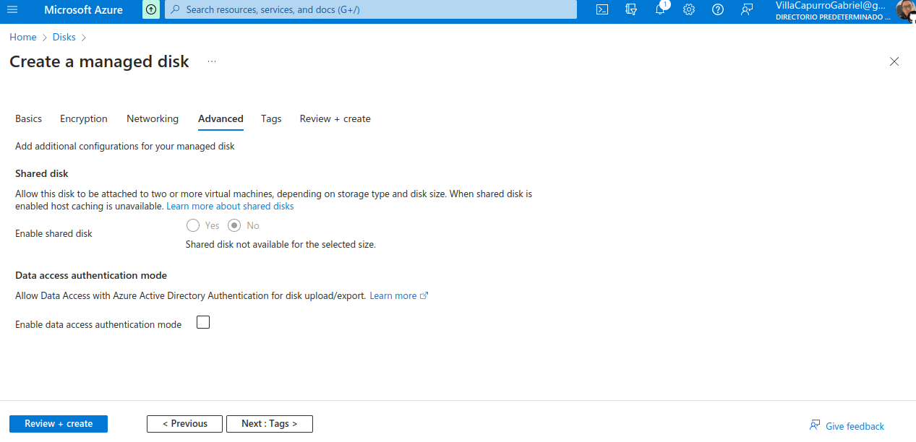

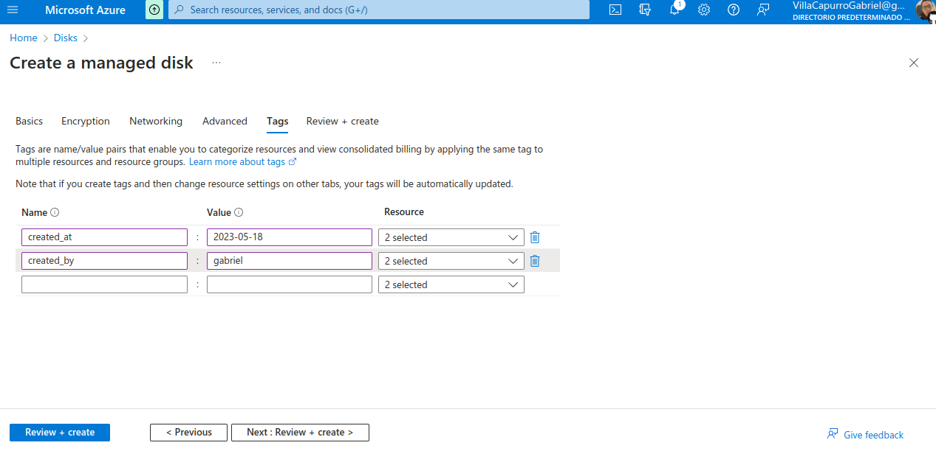

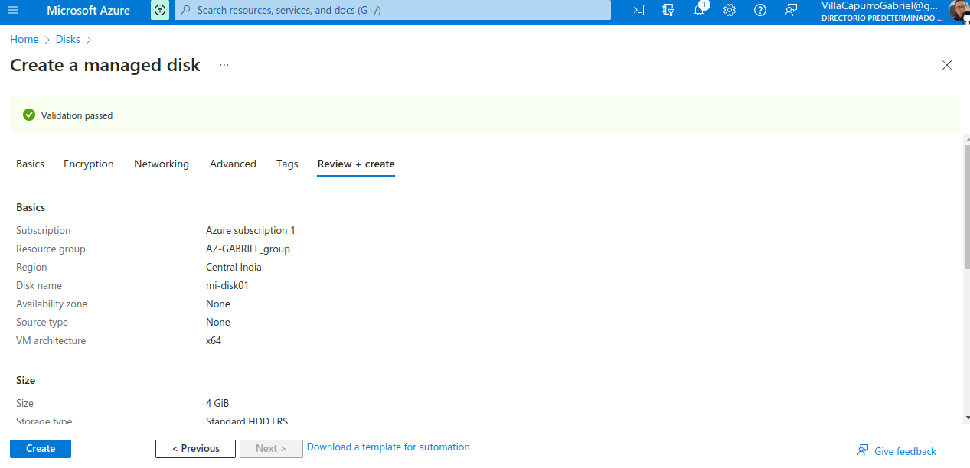

We can dowload the template of the disk



